Belfast to Donegal
Cycle for @DeterMND
REGISTRATION FORM, MAY 2018
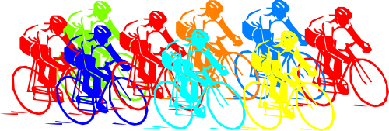

Forename: ____________________________ Surname: ________________________________

DOB: _____/_____/______ Age: _______ Please Circle: Male Female

Address: _____________________________________________________________________

____________________________________________ Post Code: ______________

Telephone: _______________________________ Mobile: _______________________________

E-mail: _______________________________

Do you have any disabilities? (Please describe): __________________________________________

________________________________________________________________________________

Do you have any medical conditions or allergies? (Please describe):_________________________

________________________________________________________________________________

Signed: _______________________________________ Date: __________________________

